Day 62: SR Latch Using NOR Gates

Introduction: An SR latch is a sequential circuit that stores one bit of data. It is constructed using two cross-coupled NOR gates.
Inputs:
- S – Set input
- R – Reset input
Outputs:
- Q – Normal output
- Q̅ – Complementary output

Truth Table
S |  | R |  | Q | Q̅ | Operation
0 | 0 |  | Previous Q |  | Previous Q̅ | Hold
0 | 1 |  | 0 |  | 1 | Reset
1 | 0 |  | 1 |  | 0 | Set
1 | 1 |  | 0 |  | 0 | Invalid

Working
- Hold: When S = 0 and R = 0, the latch retains its previous state.
- Reset: When S = 0 and R = 1, Q = 0.
- Set: When S = 1 and R = 0, Q = 1.
- Invalid: When both inputs are 1, both outputs become 0.

Gate-Level Design

Design:

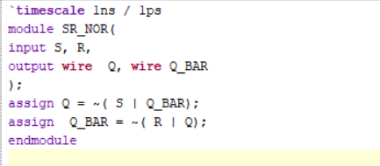

Waveform:

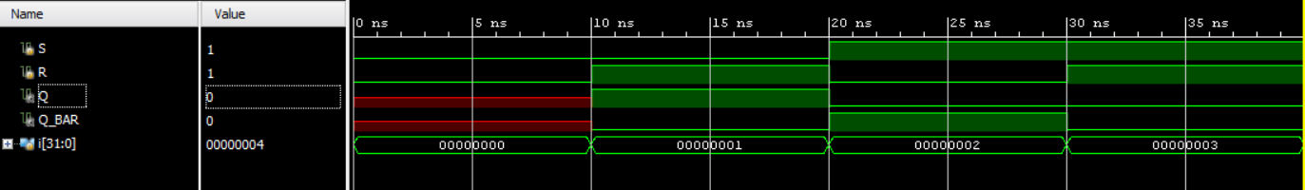

Schematic:

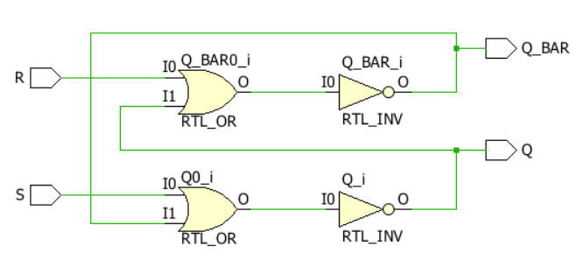

Behavioral-Level Design

Design:

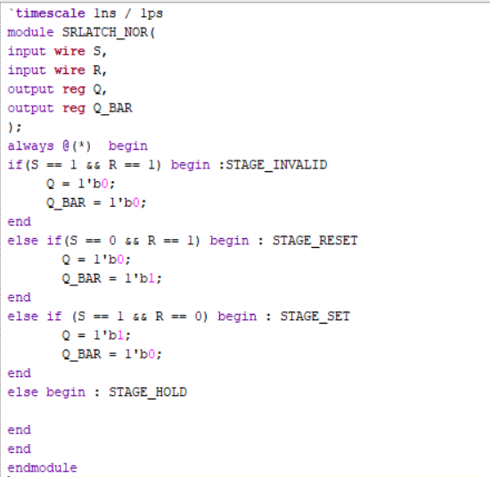

Waveform:

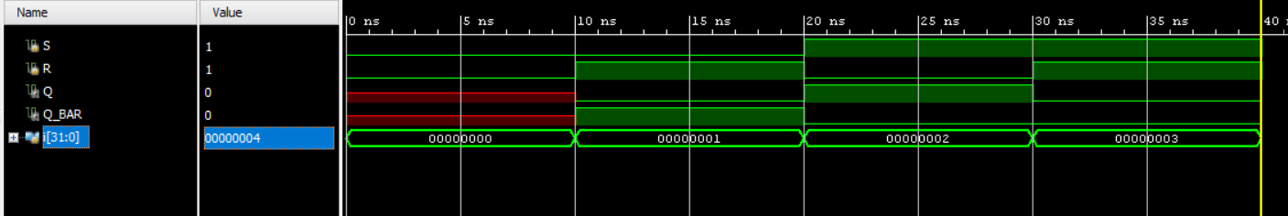

Schematic:

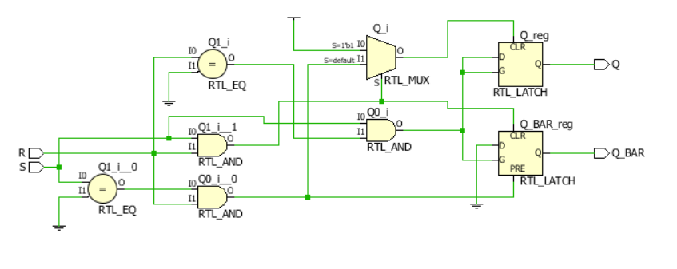

Testbench

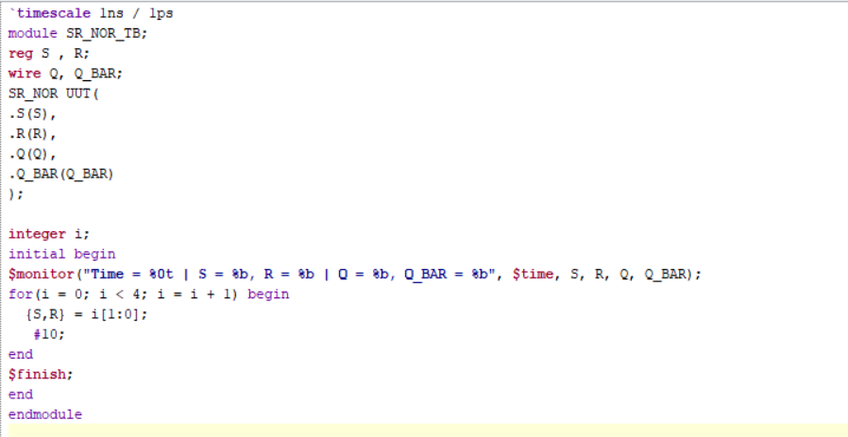

Observation:
Observation: The gate-level and behavioral-level SR latch designs were simulated successfully in Vivado using the same testbench. The waveforms verified the set, reset, and hold operations. Both designs produced the expected outputs for the given inputs.

#PHANEENDRA.SINGUDASU

